The smart contract is developed by following videos from dapp university.

The main voting function was added.
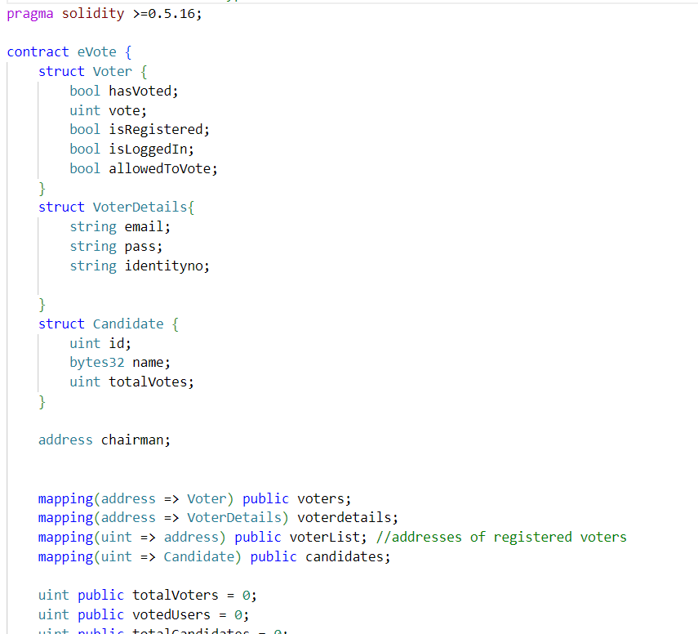

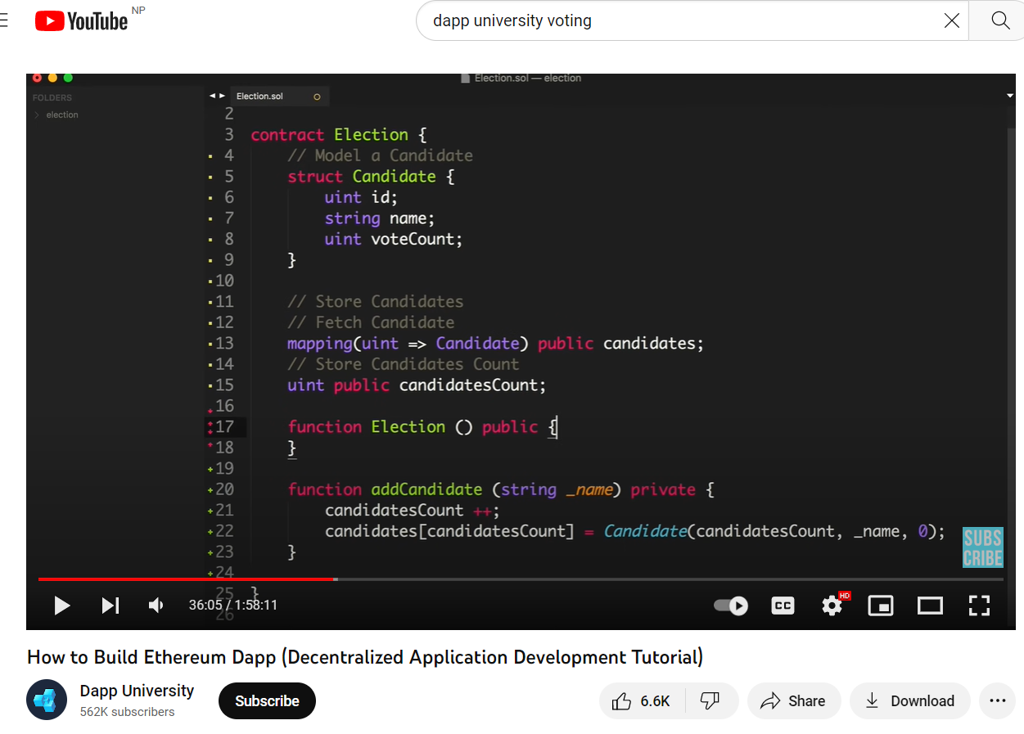

Link: https://www.youtube.com/watch?v=3681ZYbDSSk&ab_channel=DappUniversity

